# User Guide to Use Rockers Framework with Selenium Web Driver for Automation Testing

# Index

1. Pre Installation Requirements . . . . . . . . . . . . . . . . . . . 02
2. Installation Guide. . . . . . . . . . . . . . . . . . . . . . . . . . . . . .03
3. Root Structure. . . . . . . . . . . . . . . . . . . . . . . . . . . . . . . . 05
4. Step By Step Guide To Use Rockers Framework . . . . .06

***

* - Pre Installation Requirements - -

1. Windows OS minimum XP
2. Microsoft Office minimum 2007
3. Java 1.7.0
4. Maven 3.1.1
5. Ant 1.9.2

1. Blat 3.1.1 full
2. All_Jars Folder
3. Mozilla Firefox, Internet Explorer, Google Chrome, Apple Safari.
4. Eclipse Kepler for java (Optional:- If you want to run Tests from Eclipse)

***

* - Installation Guide - -

To install maven carefully follow below steps:-

1) Go to <http://maven.apache.org/download.cgi> and download maven and Open it and extract to specific location and remember that path.

For Example Mine is C:\Program Files\Apache Software Foundation\apache-maven-3.1.1 see your path to root directory that is "apache-maven-3.1.1"

2) Now Right click On My Computer and click On Advanced and then click on Environment Variables. Now See in System Variables.

Click on New and type JAVA_HOME in variable name and in variable value give path of your jdk like mine is "C:\Program Files\Java\jdk1.7.0_45"

3) Now Again Click on new and type M2_HOME in variable name and in variable value give path of your root directory that is "apache-maven-3.1.1" like mine is "C:\Program Files\Apache Software Foundation\apache-maven-3.1.1"

4) Now You have path variable already there select it and click on edit and in variable value append “;%JAVA_HOME%\bin;%M2_HOME%\bin;”

5) To confirm maven installed open command prompt and write mvn --version if not working then restart cmd and then try again.

To install ant carefully follow below steps:-

1) Go to <http://ant.apache.org/bindownload.cgi> and download ant.

2) Extract downloaded zip at one location and remember that path. Now Add a new environment variable ANT_HOME and value to you root folder for ant like mine is "C:\Program Files\apache-ant-1.9.2".

3) Now You have path variable already there select it and click on edit and in variable value append “;%ANT_HOME%\bin;” And just open your cmd and type ant –version

***

- - Root Structure - -

In Rockers Framework Project there are three packages.

1. com.rockers.Test
2. com.rockers.xlsxFiles
3. com.rockers.xlsxReader
4. com.rockers.Test :- It contains three java files (1) DriverScript.java (2) Keywords.java and (3) Constants.java

And DriverScript.java is our entry point for our tests and we just need to run that java file only.

1. com.rockers.xlsxFiles:- It has Microsoft .Xlsx files in which you writes test case names and test steps.
2. com.rockers.xlsxReader:- It has Xls_Reader.java file which contains logic to read .Xlsx files

You have “ScreenShots” Folder in which we take screen shot of our browser window when some test step fails.

***

Step By Step Guide To Use Rockers Framework

1. Open “pom.xml” file in “Rockers Framework” folder with text editor and make changes like below image:-

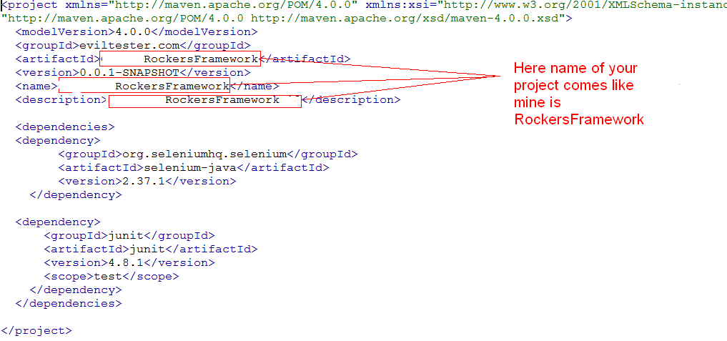

1. Now You have build.xml file in “Rockers Framework” folder so open it and make change as you can see from below image :

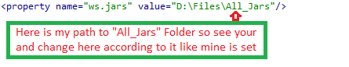

1. Now change another thing in build.xml file as shown in below image:-

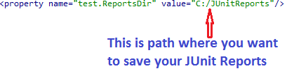

In above image “C:/JUnitReports” is my path where I want to save JUnit Reports so create an empty folder and give its path in build.xml as specified line shown in above image. So change it according to your preference.

1. Our Starting file is “TestSuites.xlsx” and it is located in Rockers Framework->src->com->rockers->xlsxFiles. So open it and you have following sheets.

TestSuite-sheets.PNG

1. No w in “Test Suite” sheet You have Three columns named

1) TSID: - Test Suite ID

2) Description: - Test Suite Description

3) Runmode: - It must be either “yes” or “no” and no other value is allowed. See below Image:-

TestSuite-Test Suite Sheet.PNG

1. Now for ex. here Registration is our module and we want to test Registration module or suite so we have Runmode “yes” and if we do not want to test that module then just write ‘no” in corresponding “Runmode” column. So this will apply to all Test Suites in “TestSuites.xlsx” file. Remember in which order you write TestSuite names in “TSID” column in that order all Test Suites will be executed. So order is important and if you do not want to test particular suite then just simply place “no” in “Runmode” column.
2. Now Open “KeyValue” sheet and there are two columns one is “Key” and other one is “Value”. see below image :-

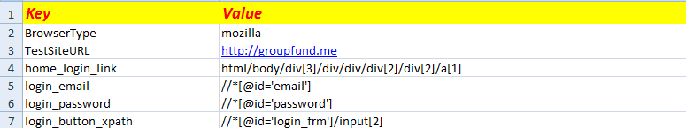

1. See Row by row first write whatever browser you want to use for you test. There are 4 browsers that you can use for your tests.
2. Mozilla Firefox - mozilla
3. Internet Explorer - internetexplorer
4. Google Chrome - googlechrome
5. Apple Safari - safari

For Each browser you have some value stored for “BrowserType” key as written above. Remember you can give any name to key but for these browsers to use you have to write above specified word in value.

You store URL of your site here as shown in above image. Remember you must have to use http:// not [www.](http://www.) Otherwise you will face an error so for ex. “http://test.com”

Now see in below rows you can see that there are xpaths stored in “Value” column. Now in it you can write any xpath related to that web element in “Key” column for which you are storing xpath like mine is “home_login_link” in “Key” column and in “Value” column I have stored xpath of that login link. And this will apply to all xpaths will be stored for your different Test Suites and All Test Cases in it.

Now when we want to take any action on any web element we just use its “Key” from “KeyValue” Sheet. It is same for Browser Type and TestSiteURL. We store its value and always use it with its key.

Question may occur why use this concept of Key-Value because if in future if xpath of your web element changes then you just need to update only here and save your time.

1. Now see “Title” Sheet and there is only one column and that is “Title For Mail”. See below Image :-

TestSuite-Title sheets.PNG

Write any Title To your Test as i have given “Rockers Tests”. It will be displayed on the top of mail body when you receive mail after tests will be completed.

1. Now you must have .xlsx file for each of your Test Suite name. For ex. As Described above we have “Registration” suite so create a new .xlsx file named “Registeration.xlsx” file in same folder.
2. Now open that suite. And take below steps in it. Remember this steps will be same for each Test suite that you will add in “TestSuites.xlsx”
3. Create a new sheet named “Test Cases” and create three columns as shown in below image :-

SuiteName-Test Cases Sheet.PNG

1. TCID - Test Case ID
2. Description - Description of Test Case
3. Runmode - Runmode of Test Case it must be either “yes” or “no” and no other value is allowed.
4. The Order in which you write Test case names they are executed in that order too. Like as seen in above image First LoginTest and Then SighUpTest will be executed. So order is important and if you do not want to test particular test case then just simply place “no” in “Runmode” column. Suppose if I write “no” in “Runmode” column for “LoginTest” and “yes” for “SignUpTest” then “LoginTest” will be skipped and “SignUpTest” will be executed. See below Image :-

runmode-no-demo.PNG

1. Now Create “Test Steps” sheet in current suite. And in that sheet create following columns as shown in below image and data written in each column and cell ignore it here and I will explain you after sometime.
2. TCID - Test case ID
3. TSID - Test Step ID
4. Description
5. Keyword - Keyword to execute tests
6. Object - to pass key of xpath
7. Data - to pass data for test case name. For ex. Username and password for Login Test.

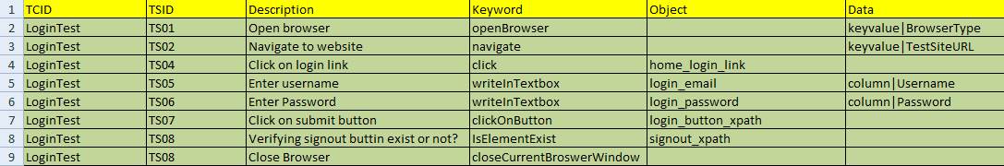

1. Now create a sheet with same name as Test case name. Here my test case name is “LoginTest” so create a sheet with that name. Same apply to “SignUPTest” and all other test cases. This sheet will contain data to test that particular test in our case it is “LoginTest”.
2. Now in this sheet add “Runmode” column additionally you create columns and add data according to your requirements for that test case. For ex. In my “LoginTest” we need to pass username and password data so i have created two columns “Username” and ”Password” as seen in below image.

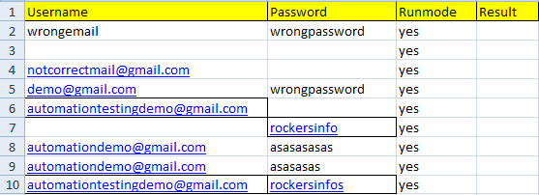

See you do not need to write anything in Result column because when test over it will automatically write pass or fail for runmode “yes” and skip for runmode “no”. But Remember you need at least one row of data to run that test otherwise that test will not run because there is no data to run it even if its runmode is “yes”. So for any test to run you must have runmode “yes” and sheet with same name as test case name and must be one data in that sheet with runmode “yes”.

1. Now open “Test Steps” sheet in current suite I mean current “.xlsx” file that you have already created just before. Now follow below instructions to know what to write in each column.
2. In “TCID” column write test case name for ex. “LoginTest” and it must be same as written in “Test Cases” sheet and apply to all test cases.
3. “TSID” column write serial no with prefix like TS01 , TS02 . . .
4. In “Keyword” column write keyword and you find all keywords with its simple Description in “Keywords.xlsx” file in Document folder. This keyword is according to your need. For ex. For “LoginTest” a human being what will do?
5. He/she first opens browser.
6. Then type URL to navigate to site to test.
7. On home page he will click on login link.
8. Then he will write Username in Textbox
9. Then he will write Password in Textbox.
10. Then he will click on Login Button.
11. And then ensure that login is successful or not he will identify some functionality or button that only comes after login like Sign out button.
12. Then he will close the browser.

The same steps I have written in “Test Steps” sheet. For each action you need one keyword and that you will find in “Keywords.xlsx” file. For ex. In case of “LoginTest” see below image:-



1. See “Keyword” column in above image and you simply understand eight steps that I have explained above.
2. Write description of each keyword in “Description” column.
3. In “Object” column we will only pass xpath of web element but not directly but we will pass key of xpath that we have stored in “KeyValue” sheet of “TestSuites.xlsx” file. For “opneBrowser” and “navigate” keyword we have nothing to write in “Object” column but we pass data for them “Data”. For ex. In case of “LoginTest” I have written “home_login_link” in 4th row in “Object” column and from where it comes? To know it just see below Image:-

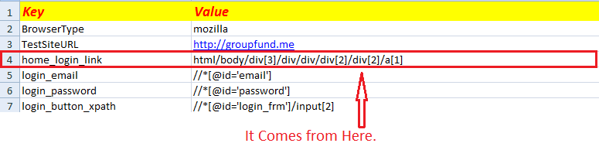

1. In “Data” column we pass data. For ex. BrowserType , TestSiteURL and data for that Test. So in data column your data may come from either “KeyValue” Sheet or sheet with same name as current test case name. So you need to specify prefix either “column” or “keyvalue” and then write corresponding data. For ex. In case of “LoginTest” I have written “keyvalue|BrowserType” means prefix and key from “KeyValue” sheet of “TestSuites.xlsx” file and both are separated by “|” i.e. pipe. And I have written that “column|Username”. Means prefix and then “|” pipe and then name of column where your data is stored like to enter username in textbox I need data from “Username” column from “LoginTest” sheet. Remember for “Object” column xpaths are coming from “KeyValue” sheet of “TestSuites.xlsx” file but there you do not need to use prefix “keyvalue” and no need to use pipe “(|)”. Because data in “Object” always come from “KeyValue” sheet but in “Data” column your data either come from “KeyValue” sheet or sheet with same name as test case name.Just see below image: -

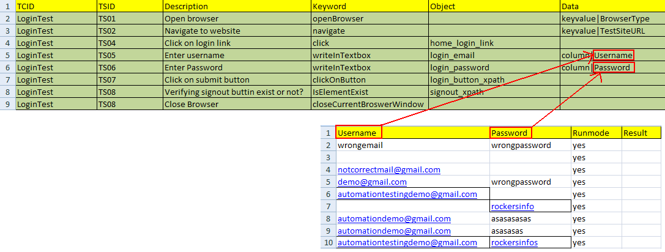

1. Now for all test cases in all test suites you need to follow above instructions.
2. When all tests are completed you will find “Result” columns will be automatically generated in “Test Steps” sheet for each and every step in particular suite. And this will be added after “Data” column See below Image:-

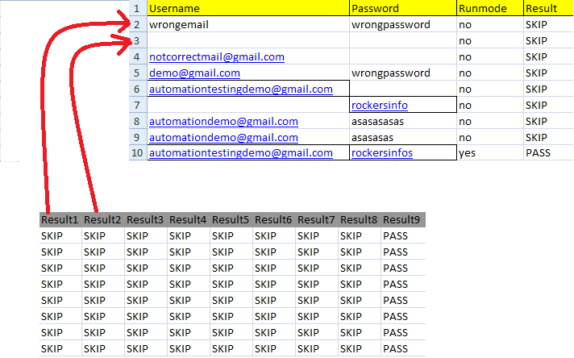

“Result1” column will be for row no. 2 in sheet with same name as current test case name and “Result2” for row no. 3 and so on for all columns in “Test Steps” sheet. Remember you will never write anything in any “Result” column it will automatically write “PASS” or “FAIL” for “Runmode” “yes” and will write “SKIP” for “Runmode” “no”.

1. Now if you want to use bat file then you will find “Rockers Framework” batch file in “Rockers Framework” folder and open it with notepad or any other text editor. And it looks like as shown in below image:-

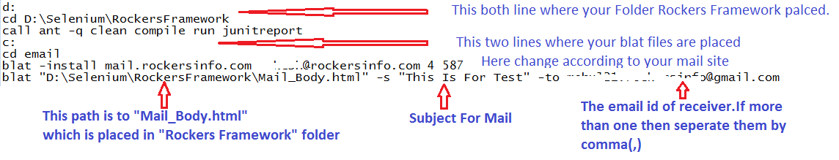

The first two lines which are “d:” and “cd D:\Selenium\RockersFramework” is your path to “Rockers Framework” folder and line after this is not need to change but after that there two lines which are “c:” and “cd email” is path to your blat file.

And after that line is need to change according to your mail site. For ex if your site is <http://test.com> then that line would be “blat -install mail.test.com <your username >@test.com 4 587”. Here 587 is port number so if your port is other than 587 then change it.

1. Now to run your tests just make changes in Excel files with run mode either “yes” or “no” and after that just double click on batch file named “Rockers Framework” and all your tests will run and you receive Mail to ids specified by you as stated above and in that Mail just click on “HTML Report” link and in newly opened page you can see test case names and pass or fail or skip. Now if it is “FAIL” then just click on it and it will redirect you new page in which you can see screenshot to know why error has occurred.
2. You have “view_image.html” file in “Rockers Framework” folder and you must NOT delete that file and also do not delete any file in that folder.

***